**BLINKIT ANALYSIS PROJECT**

#Creating the database

create database blink;

#Using the database

use blink;

#Total no.of rows

select count(*) from blinkit;

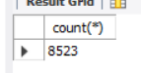

select *from blinkit;

#data cleaning

UPDATE blinkit

SET `Item_Fat_Content` =

CASE

WHEN `Item_Fat_Content` IN ('LF', 'low fat') THEN 'Low Fat'

WHEN `Item_Fat_Content` = 'reg' THEN 'Regular'

ELSE `Item_Fat_Content`

END;

Describe blinkit;

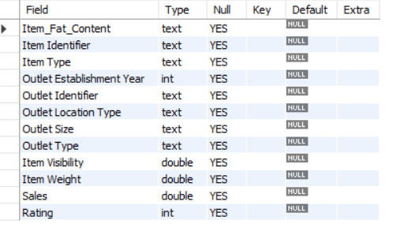

SELECT DISTINCT `Outlet Establishment Year` FROM blinkit;

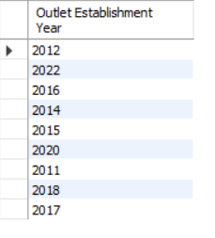

SET SQL_SAFE_UPDATES = 0;

**#total sales**

select sum(Sales) as Total_sales

from blinkit;

select cast(sum(Sales)/1000000 as decimal (10,2)) Total_sales_in_millions

from blinkit; #to show in millions

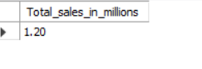

**#Avg sales**

select avg(Sales) as Avg_sales

from blinkit;

select cast(avg(Sales) as decimal(10,2)) as Avg_sales

from blinkit;



**#number of items**

select count(*) as number_of_items from blinkit;

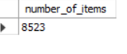

**#total sales for low fat**

select cast(sum(Sales) as decimal (10,2)) Total_sales_for_lowfat

from blinkit

where Item_Fat_Content="Low Fat";



**#total sales for establishment year of 2023**

select cast(sum(Sales) as decimal (10,2)) Total_sales_in_2022

from blinkit

where `Outlet Establishment Year`=2022;



**#Average sales for establishment year of 2023**

select cast(avg(Sales) as decimal (10,2)) Avg_sales_in_2022

from blinkit

where `Outlet Establishment Year`=2022;

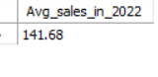

**#Average rating**

select cast(avg(Rating) as decimal(10,2)) Avg_Rating from blinkit;



**#Granular Requirement#**

**#Total sales by Item fat content**

select Item_Fat_Content,cast(sum(Sales) as decimal(10,2)) as Total_sales_for_ItemFatContent

from blinkit

group by Item_Fat_Content

order by Total_sales_for_ItemFatContent desc;

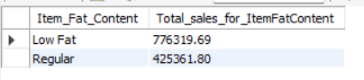

**#Total ,Avg,Count of sales for Item Fat Content**

select Item_Fat_Content,

cast(sum(Sales) as decimal(10,2)) as Total_sales_for_ItemFatContent,

cast(avg(Sales) as decimal(10,2)) as Avg_sales_for_ItemFatContent,

count(*) as no_of_items,

cast(avg(Rating) as decimal(10,2)) as Avg_Rating_For_ItemFatContent

from blinkit

group by Item_Fat_Content

order by Total_sales_for_ItemFatContent desc;

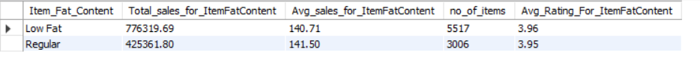

**#Total sales by item type**

select `Item Type`,cast(sum(Sales) as decimal(10,2)) Total_sales_by_ItemType

from blinkit

group by `Item Type`

order by Total_sales_by_ItemType desc;

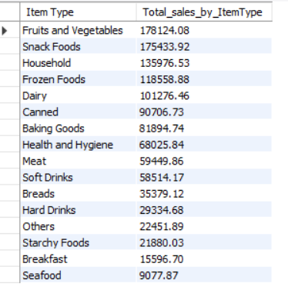

**#Total,avg,count of item type**

select `Item Type`,

cast(sum(Sales) as decimal(10,2)) Total_sales_by_ItemType,

cast(avg(Sales) as decimal(10,2)) Avg_sales_by_ItemType,

count(*) as no_of_items,

cast(avg(Rating) as decimal(10,2)) Avg_Rating

from blinkit

group by `Item Type`

order by Total_sales_by_ItemType desc;

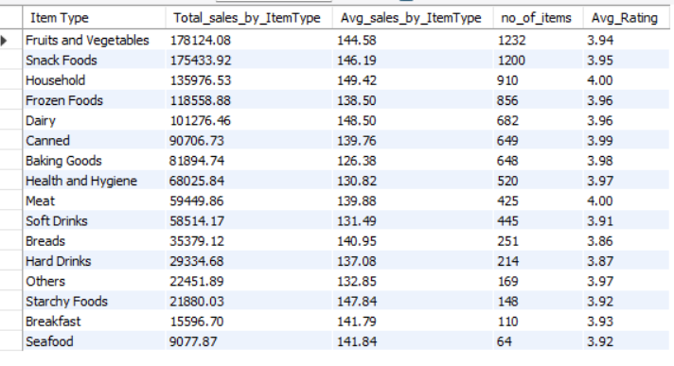

**#ItemFatContent by outlet for total sales**

select `Outlet Location Type`,Item_Fat_Content,cast(sum(Sales) as decimal(10,2)) as total_sales

from blinkit

group by `Outlet Location Type`,Item_Fat_Content;

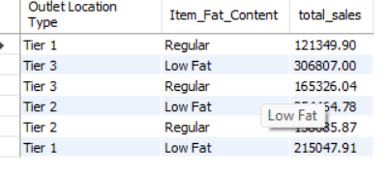

**#ItemFatContent by outlet for total sales,avg** **sales,count,avg rating**

select `Outlet Location Type`,Item_Fat_Content,

cast(sum(Sales) as decimal(10,2)) as total_sales,

cast(avg(Sales) as decimal(10,2)) as avg_sales,

count(*) as no_of_items,

cast(avg(Rating) as decimal(10,2)) as Avg_Rating

from blinkit

group by `Outlet Location Type`,Item_Fat_Content;

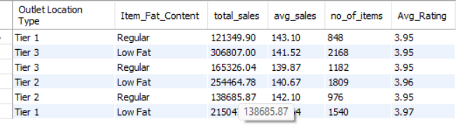

SELECT

`Outlet Location Type`,

round(SUM(CASE WHEN `Item_Fat_Content` = 'Low Fat' THEN Sales ELSE 0 END), 2) AS `Low Fat`,

round(SUM(CASE WHEN `Item_Fat_Content` = 'Regular' THEN Sales ELSE 0 END), 2) AS Regular

FROM blinkit

GROUP BY `Outlet Location Type`;

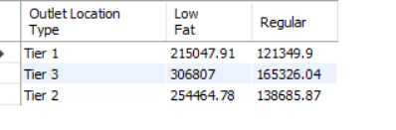

**#total sales by establishment year**

select `Outlet Establishment Year`,

cast(sum(Sales) as decimal(10,2)) total_sales

from blinkit

group by `Outlet Establishment Year`

order by `Outlet Establishment Year`;

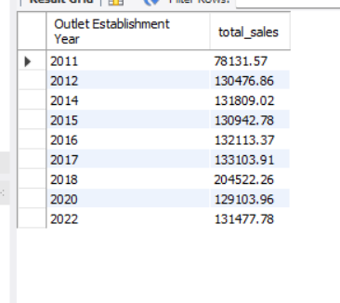

**#total ,avg,count,avg rating sales by establishment year**

select `Outlet Establishment Year`,

cast(sum(Sales) as decimal(10,2)) total_sales,

cast(avg(Sales) as decimal(10,2)) as avg_sales,

count(*) as no_of_items,

cast(avg(Rating) as decimal(10,2)) as Avg_Rating

from blinkit

group by `Outlet Establishment Year`

order by `Outlet Establishment Year` asc;

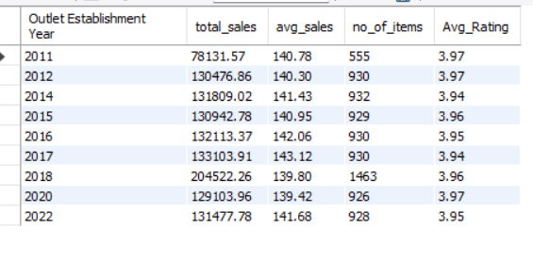

**#percentage of sales by outlet size**

select `Outlet Size`,

round(sum(Sales),2) as Total_sales,

round(sum(Sales)*100.0/

(select sum(Sales) from blinkit),2)as Sales_percentage

from blinkit

group by `Outlet Size`

order by Sales_percentage desc;

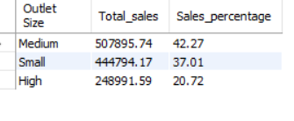

**#sales by outlet location**

select `Outlet Location Type`,

round(sum(Sales),2) as Total_sales_by_OutletLocation

from blinkit

group by `Outlet Location Type`;

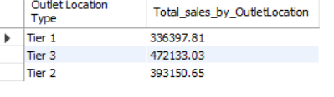

**#total,avg,count,avg rating sales by outlet location**

select `Outlet Location Type`,

round(sum(Sales),2) as Total_sales_by_OutletLocation,

round(avg(Sales),2) as avg_sales_by_OutletLocation,

count(*) as no_of_items,

round(avg(Rating),2) as Avg_Rating_for_OutletLocation

from blinkit

group by `Outlet Location Type`;

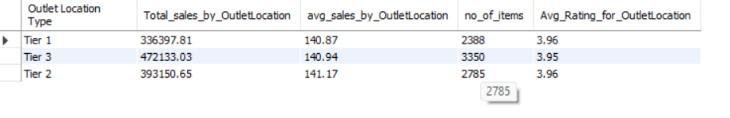

**#all metrics by outlet type**

select `Outlet Type`,

round(sum(Sales),2) as Total_sales_by_OutletType,

round(avg(Sales),2) as avg_sales_by_OutletType,

count(*) as no_of_items,

round(avg(Rating),2) as Avg_Rating_for_OutletType

from blinkit

group by `Outlet Type`

order by Total_sales_by_OutletType desc;

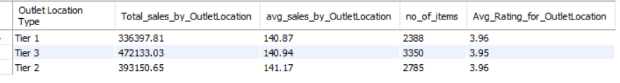

**#Top 10 highest-selling items**

select `Item Type` ,

round(sum(Sales),2) as Sales

from blinkit

group by `Item Type`

order by Sales desc

limit 10;

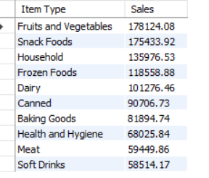

**#lowest 10 performing item type**

select `Item Type` ,

round(sum(Sales),2) as Sales

from blinkit

group by `Item Type`

order by Sales asc

limit 10;

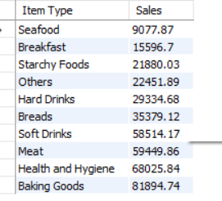

**#Sales per item**

select `Item Type` ,

round(sum(Sales)/count(distinct `Item type`),2) as Total_Sales_per_itemType

from blinkit

group by `Item Type`;

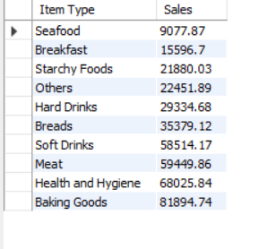

**#sales per outlet**

select `Outlet Type` ,

round(sum(Sales)/count(distinct `Outlet Type`),2) as Total_Sales_per_OutletType

from blinkit

group by `Outlet Type`

order by Total_Sales_per_OutletType desc;

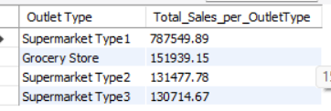

**#year growth by sales**

WITH yearly_sales AS (

SELECT

`Outlet Establishment Year` AS year,

SUM(Sales) AS total_sales

FROM blinkit

GROUP BY `Outlet Establishment Year`

)

SELECT

year,

total_sales,

LAG(total_sales) OVER(ORDER BY year) AS prev_year_sales,

ROUND(((total_sales - LAG(total_sales) OVER(ORDER BY year)) /

LAG(total_sales) OVER(ORDER BY year)) * 100, 2) AS growth_percentage

FROM yearly_sales

ORDER BY year;

